**UPPER RIO GRANDE WATER OPERATIONS MODEL**

**URGWOM_Database_June2024.dss Documentation**

**VOLUME 4**

Version 9.3

September 26th, 2024

*Submitted to:*



U.S. Army Corps of Engineers

Albuquerque District

4101 Jefferson Plaza NE

Albuquerque, New Mexico 87109

*Prepared by:*

**

Tetra Tech, Inc.

6121 Indian School Road NE, Suite 205

Albuquerque, New Mexico 87110

**Tetra Tech Inc.: Contract W912PP-15-D-0023, Delivery Order No. W912PP17F0015**

Page Intentionally Left Blank

# Table of Contents

Table of Contents iii

List of Figures iii

List of Tables iii

Abbreviations and Acronyms Used iii

Introduction 1

DSS Structure 2

Metadata 3

3.1 Metadata Storage in DSS 3

3.2 Metadata Workbook Catalog 3

# List of Figures

Figure 1: URGWOM_Database_Mar2019 Catalog.xlsx showing user selection of a single record (in yellow) and resulting display of associated metadata 5

# List of Tables

Table 1: Example DSS Database Record and Parts A-F 3

# Abbreviations and Acronyms Used

AOP Annual Operating Plan

CADSWES Center for Advanced Decision Support for Water and Environmental Systems

DMI Data Management Interface

DSS Hydrologic Engineering Center Data Storage System

HEC-DSS Hydrologic Engineering Center Data Storage System

URGWOM Upper Rio Grande Water Operations Model

workbooks Microsoft Excel Workbooks

# Introduction

URGWOM (The Upper Rio Grande Water Operations Model) was developed with the RiverWare software application developed at the Center for Advanced Decision Support for Water and Environmental Systems (CADSWES) at the University of Colorado at Boulder. The model is a daily or monthly timestep model for simulating operations of facilities and diversions along the Rio Grande and major tributaries within Colorado, New Mexico, Texas, and Mexico.

This document is intended to inform users about the data that exists in the URGWOM database. URGWOM uses the Hydrologic Engineering Center Data Storage System (HEC-DSS or just DSS) to store data needed for model runs. The structure of the database is described briefly, followed by a description of legacy Microsoft Excel Workbooks (workbooks) used to store URGWOM database metadata. This document describes problems with an attempt to use the DSS database itself for metadata storage, and finally provides a description of a single workbook for management of URGWOM DSS metadata. This overview document and the associated metadata workbook should be updated as the database is updated.

Other URGWOM Documentation volumes cover such topics as Physical Simulation, Rules and Functions, Accounting Concepts and Methods, and the URGWOM Database. The URGWOM Documentation volumes are listed below. For more detailed information on URGWOM, the reader is referred to URGWOM documentation, particularly Volume 1 which describes the physical model, and Volume 2a which describes the policy rules.

**Volume 1: Physical Documentation**

**Volume 2a: Policy Rules Documentation**

**Volume 2b: Initialization Rules Documentation**

**Volume 2c: Expression Slot Functions Documentation**

**Volume 3: Accounting Concepts and Methods**

**Volume 4: Database Documentation**

**Volume 5: DMI and SCT Documentation**

**Volume 6: User's Manual (Script Documentation)**

# DSS Structure

URGWOM data is stored in US Army Corps of Engineers HEC-DSS ([www.hec.usace.arm.mil](http://www.hec.usace.arm.mil)) files. There are two DSS files used: URGWOM_Database_June2024.dss, which contains the bulk of the historical data used in URGWOM, and URGWOM_Groundwater_Database_October2023.dss, which contains 1950-2021 modeled daily groundwater data from several MODFLOW models which are used as inputs to URGWOM. Combined, these URGWOM DSS databases include nearly two thousand records of data for use in URGWOM; each record can contain thousands of individual data points. Each record is organized by Parts A-F. Each Part represents an aspect of the data within that record. In general, the following describes the aspect that each DSS Part represents, and Table 1 shows an example of a record in the database:

A Part Group

B Part Location

C Part Parameter

D Part Period of Record

E Part Time Interval (i.e., day, year, etc.)

F Part Description/Metadata

There are no records within the URGWOM database that have an A Part.

In typical DSS database structure, the B Part indicates the location associated with the data, and the C Part indicates the parameter or type of data (temperature, precipitation, diversion, storage, inflow, evapotranspiration rate, etc.) being stored. Some of the data in the URGWOM database is stored following this convention, however much is stored following a convention more specific to RiverWare modeling. In RiverWare, Data Management Interfaces (DMIs) can be used to import data from a DSS file into specific model “objects” (e.g., a Reservoir Object, a Reach Object, a Water User Object, or commonly in the case of DMIs, a Data Object) and within the object, into one of any number of “slots”. It is convenient to set up the DMI to import data from the DSS file to the RiverWare model by setting the B Part in the DSS file equal to the object name in the RiverWare model, and the C Part in the DSS file equal to the slot name in the RiverWare model object specified by the B Part. So, for example, a B Part and C Part of Heron and Inflow respectively would bring data into the URGWOM object named Heron in the slot called Inflow, Heron.Inflow in RiverWare notation, and “A Part/Heron/Inflow/D Part/E Part/F Part” in DSS notation. Insofar as the object name conveys a location, and the slot conveys a parameter, the two conventions will line up reasonably, but this doesn’t always happen.

The D Part provides the range of dates available for the record, and the E Part tells the user the timestep of the data. In the URGWOM database, the F Part generally, provides a brief description of the data source (see Metadata Storage in DSS below).

For example, the A-F Parts in Table 1 inform the user that the record represents daily inflow to Abiquiu between January 1, 1975, and December 31, 2021 and that it was obtained from the USBR. Opening the record reveals information for the unit of measurement (cfs) and all the data points. There are some records in the database for which the information in the B Part and C Part is reversed, but the B and C Parts can always be used to search for a specific parameter and/or location.

Table : Example DSS Database Record and Parts A-F

|  |  |  |  |  |  |
| --- | --- | --- | --- | --- | --- |
| **A Part** | **B Part** | **C Part** | **D Part** | **E Part** | **F Part** |
|  | ABIQUIU | MAX AIR TEMPERATURE | 01JAN1963-01JAN2021 | 1DAY | USBR ACCOUNT OUTPUT, SEE URGWOM WEBSITE FOR DETAILED METADATA |

A screenshot of how these database records appear in DSSVue

# DSSVue Software

The two URGWOM DSS databases can be opened for viewing and editing in latest version of the HEC-DSSVue software (currently version 3.4.7), found here: <https://www.hec.usace.army.mil/software/hec-dssvue/downloads.aspx>.

A screenshot of the URGWOM_Database_June2024.dss database within this software is shown below:

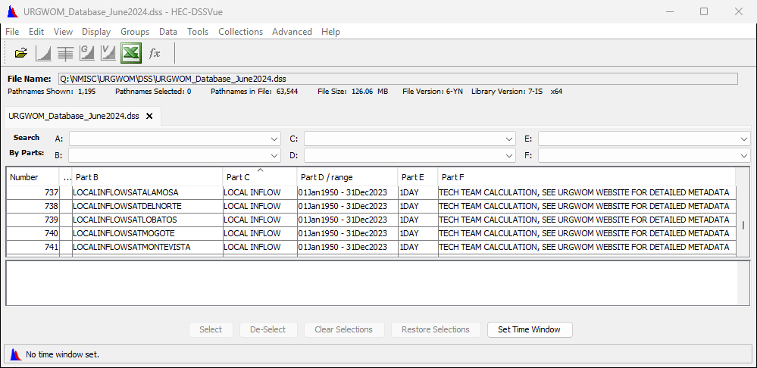

# Metadata

Metadata is information about data including its source or how it was calculated. Metadata storage in DSS is difficult, and a metadata workbook catalog is developed in Excel to allow metadata associated with DSS records to be stored and searched.

## Metadata Storage in DSS

Ideally, the HEC Data Storage System would include metadata fields, and the URGWOM Tech Team did pursue this as a solution by using the DSS F Part for metadata. This solution has two problems:

1. The F Part field can only store up to 64 characters. This limitation means that the small amount of information stored in the F Part is often used to reference other, more complete metadata. Often the reference was to the URGWOM website where eleven metadata workbooks (described below) could be found.
2. The F Part field must be specified in RiverWare DMIs. Thus, there can’t be any difference in F Part fields for a given data record, and any change to the F Part information will break any DMI accessing that data.

These limitations mean that meaningful metadata describing data in a DSS database used by RiverWare must be stored outside of the DSS. Historically this has been done with eleven legacy metadata workbooks.

## Metadata Workbook Catalog

To address the need for metadata that can be quickly accessed for any data record, in a format that is reasonably easy to maintain, and in which 1:1 mapping to the DSS database can be checked, a single metadata workbook has been developed.

The metadata workbook includes three lists, one list of all B Part / C Part combinations, and associated record specific metadata. A second list contains a list of all B Parts in the database and B Part specific metadata if any, and a third list contains a list of all C Parts in the database and C Part specific metadata if any. These lists have been set up for the URGWOM_Database_June2024.dss database. Metadata was taken from the legacy workbooks and from the READ ME sheet of the Lower Rio Grande database workbook named ‘USACE LRG Data Sep 2017.xls’ to populate the metadata lists. All information from the legacy spreadsheets was moved into the data catalog. The proposed metadata workbook catalog is named ‘URGWOM_Database_Mar2019 Catalog.xlsx’. As shown in Figure 1, a worksheet within the workbook called URGWOM DB Metadata allows selection of any record in the database (from a dropdown menu) and displays metadata from each of the three lists associated with the B Part/C Part combination, and the B Part, and C Parts individually.

It is recommended that the metadata catalog is kept with the DSS database. The metadata lists associated with B Part/C Part, and B Part and C Part are not complete. It is recommended that future work efforts are used to fill in missing metadata in these lists. It is also recommended that all future work on the database include updates to metadata associated with records that are modified, and addition or deletion of records from the metadata workbook catalog when records are added or removed from the DSS database.

With this change, it is also recommended that either the F Part be removed from all database records, or the F Part be changed in all records to be an identical reference to the URGWOM web page, and the data catalog be made available there.

A 1:1 correlation of the workbook catalog to the DSS database can be checked by generating an Abbreviated Disk Catalog from the DSS database, saving it as a text file, and manipulating it in order to import it into Microsoft Excel for comparison to the lists in the catalog workbook. This process is described in the worksheet called ‘0-ReadMe’ in the catalog workbook.

The weaknesses of the metadata workbook catalog are that there is not a dynamic connection to the DSS database, and formatting of metadata is difficult. Advantages are a simple dropdown selector and resulting metadata.

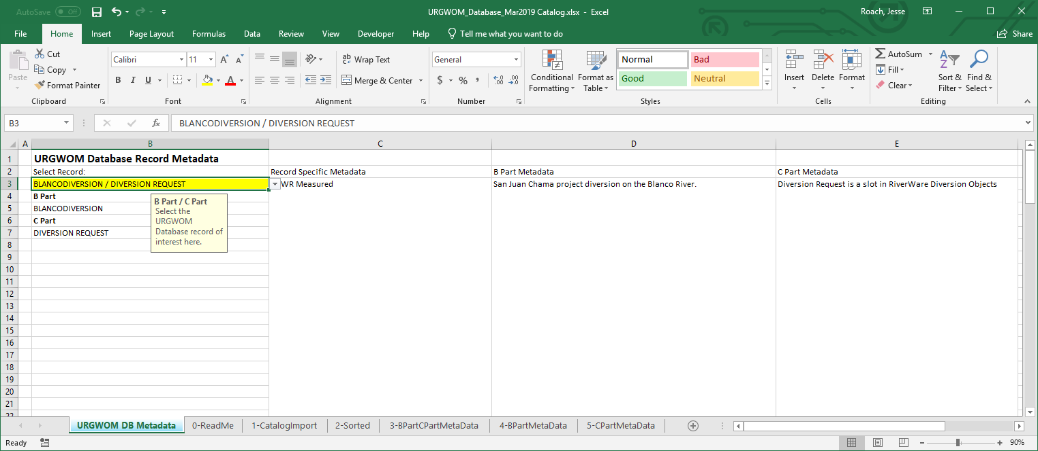

Figure : URGWOM_Database_Mar2019 Catalog.xlsx showing user selection of a single record (in yellow) and resulting display of associated metadata